**Lab Report #7**

**Sadovskaya Veronika**

**GitHub:** [**https://github.com/sdveronika/DataMola22**](https://github.com/sdveronika/DataMola22)

**Data Source -** this is the script that generated the calendar.



Next, an external table was created, which is not included in the tablespace, for overloading data into it – it’s **Stage.**



From it, using the package, the data was divided and placed in cleasing tables - this is the **DW**.

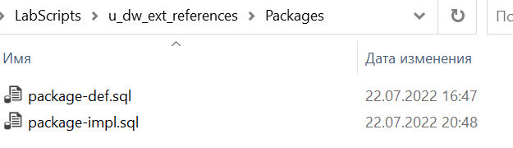

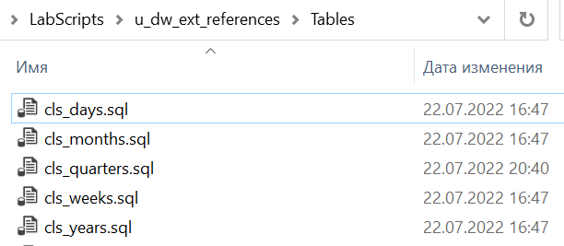

Further, from cleansing tables, the following tables were filled.

**Task 01: CREATE DW.T_DAYS**

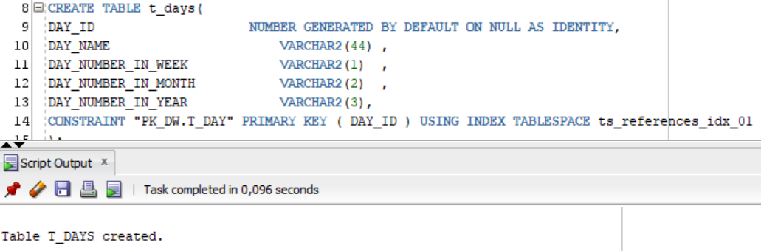

Figure 1.1 – Create table t_days

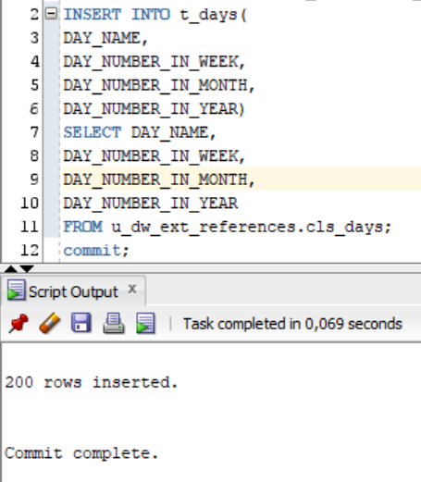

Figure 1.2 – Populate table t_days

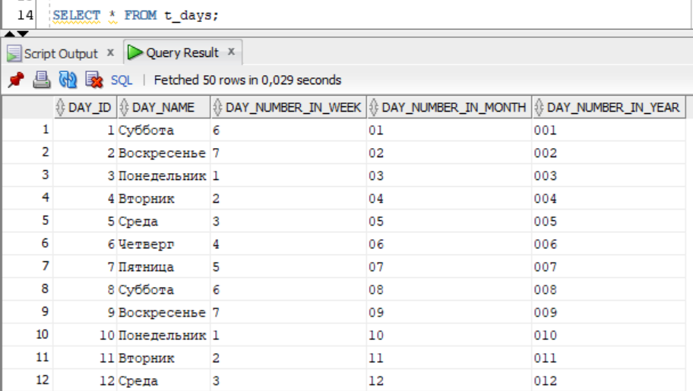

Figure 1.3 – Select from table t_days

**Task 02: CREATE DW.T_WEEKS**

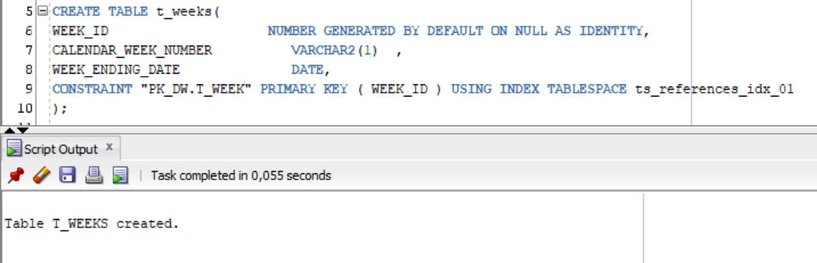

Figure 2.1 – Create table t_weeks

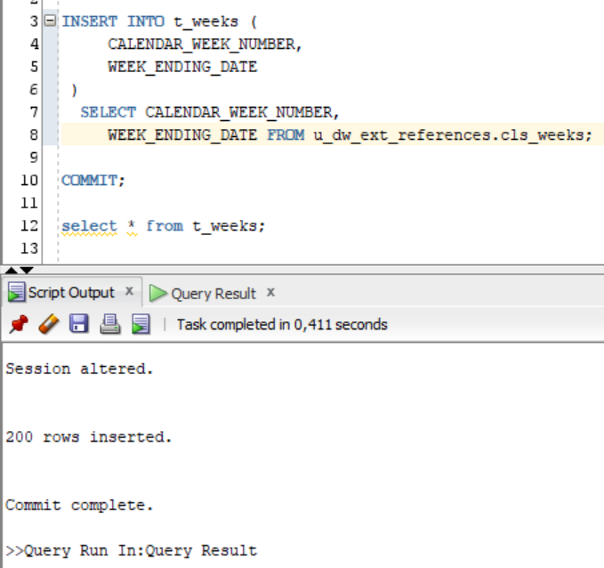

Figure 2.2 – Populate table t_ weeks

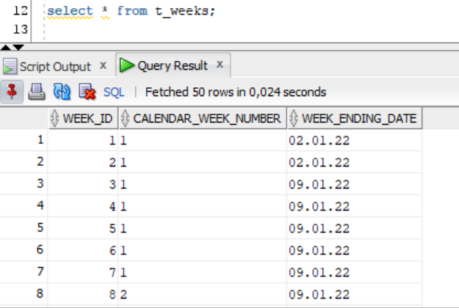

Figure 2.3 – Select from table t_ weeks

**Task 03: CREATE DW.T_MONTHS**

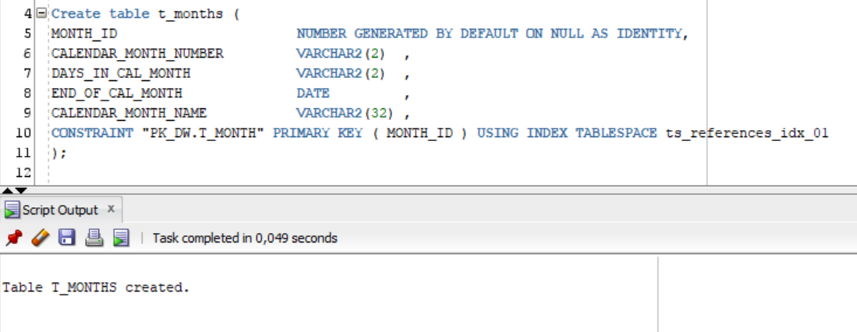

Figure 3.1 – Create table t_months

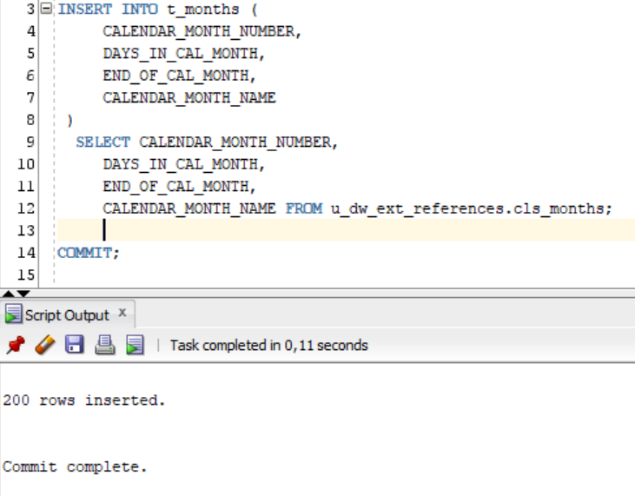

Figure 3.2 – Populate table t_ months

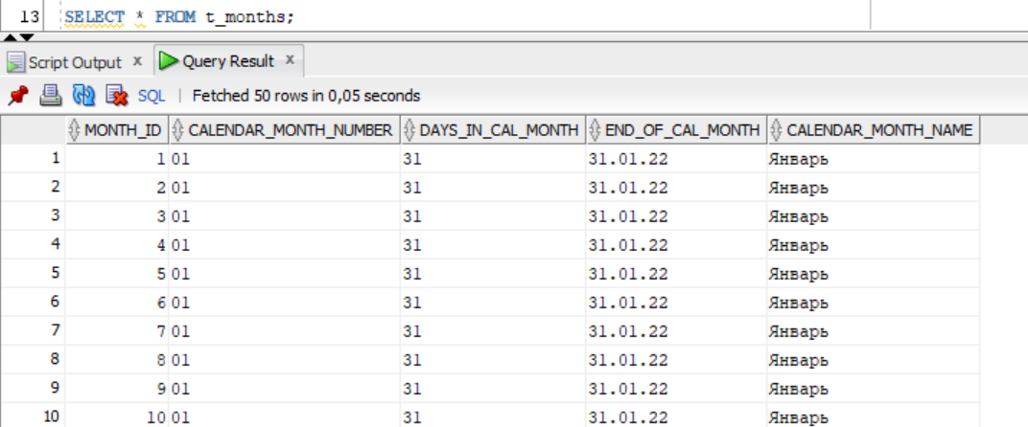

Figure 3.3 – Select from table t_ months

**Task 04: CREATE DW.T_QUARTERS**

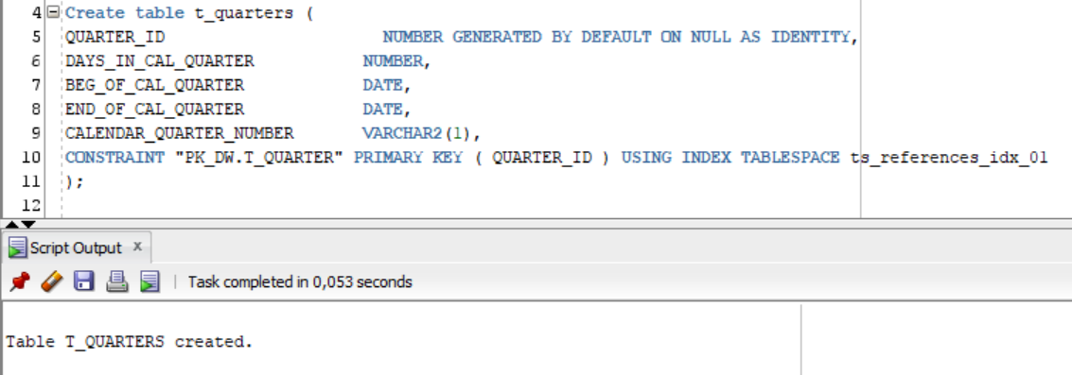

Figure 4.1 – Create table t_quarters

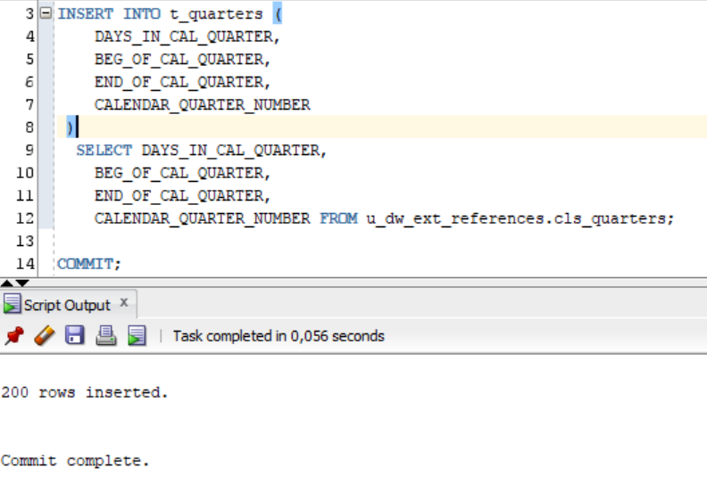

Figure 4.2 – Populate table t_ quarters

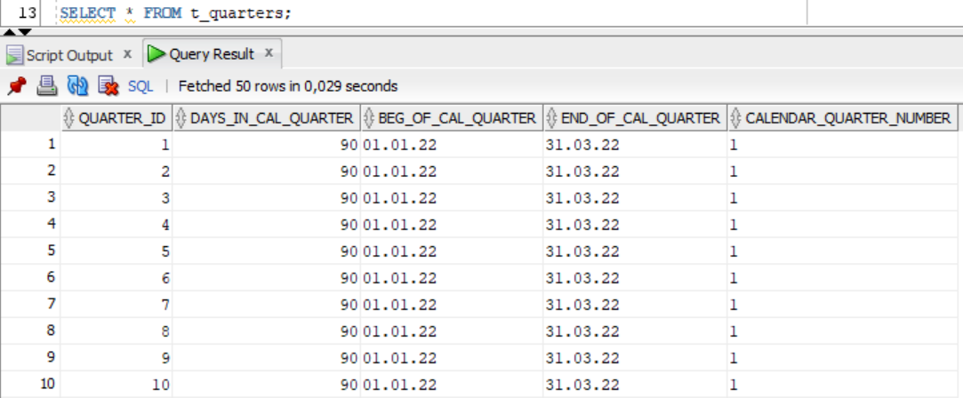

Figure 4.3 – Select from table t_ quarters

**Task 05: CREATE DW.T_YEARS**

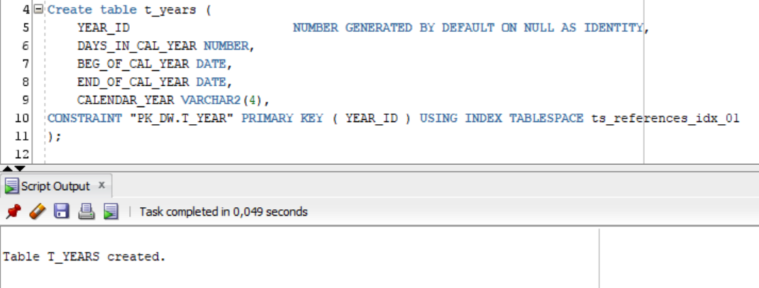

Figure 5.1 – Create table t_years

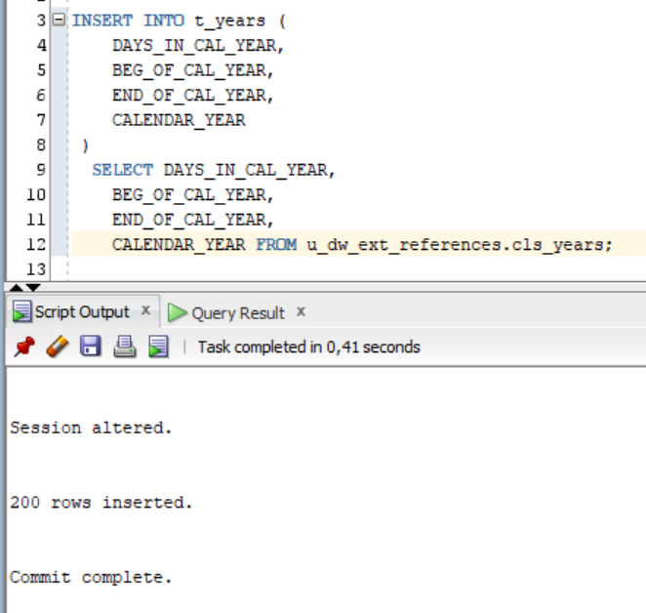

Figure 5.2 – Populate table t_ years

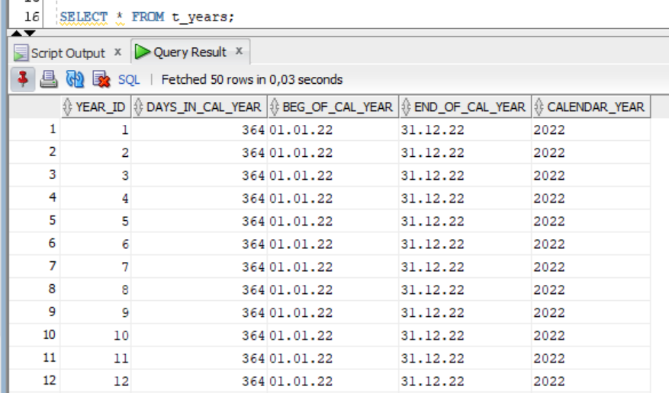

Figure 5.3 – Select from table t_ years

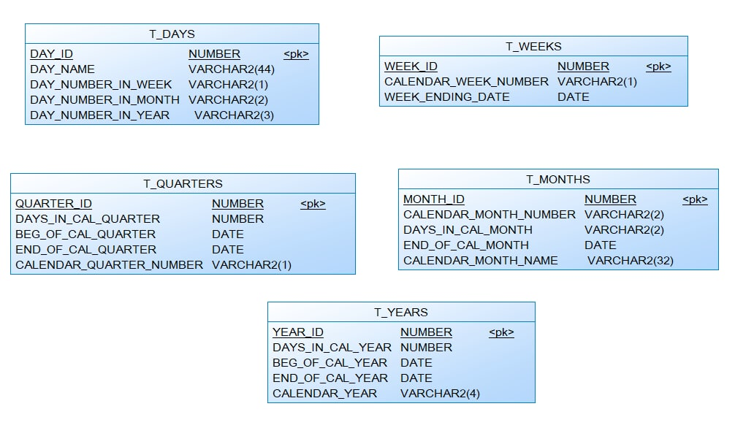

Figure – General Physical Diagram